CEAS Co-op Reflection System
D0 High-Level Design

Team Members:
Priyanshi Kulshrestha
Mbathio Lo
Maria Malik
Aradana Nair
Hinna Parwez

1. Title, Goal Statement, and Conventions
Title: Design D0: High-Level System Architecture

Goal Statement: Let CEAS co-op students reflect on each completed rotation using rotation-specific questions, give assigned advisors a clear summary with workplace supervisor observations, and keep each reflection private to the student and their assigned advisor.

Basic Input: Student reflections, supervisor evaluations, and university records with rotation numbers and advisor assignments.

Basic Output: Rotation-specific prompts and private reflection summaries with supervisor observations for students and assigned advisors.

Diagram Conventions:

- Solid rectangles: Major components developed by the team.
- Dashed rectangles: External systems or third-party services.
- Cylinders: Databases or persistent data storage.
- Directed arrows: The direction of information flow between components.
- Interface labels (I1, I2, …): Connections corresponding to entries in the interface specification table.
- Data-flow arrow labels: The information transferred and its form at that stage, such as “validated record (JSON).”

2. Block Diagram (D0 Diagram)

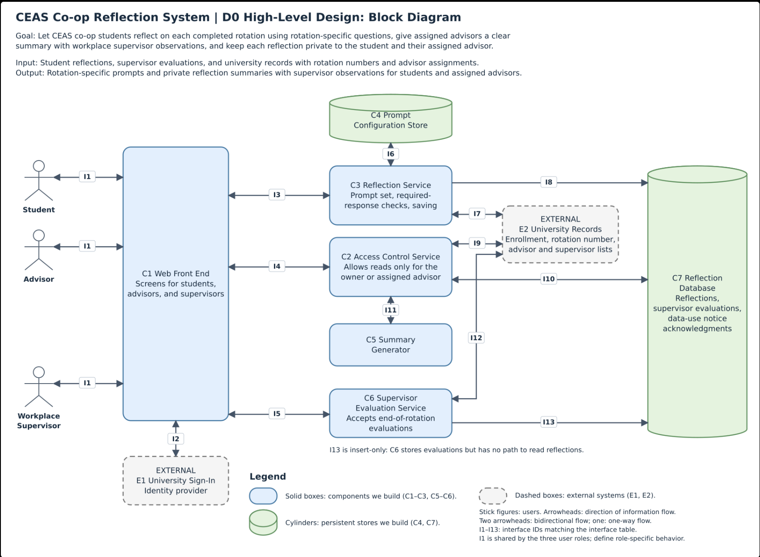

3. Component Responsibility Table

Component | Responsibility | Interfaces In | Interfaces Out | Primary Owner
C1 Web Front End | Provides the user-facing screens used by students, advisors, and workplace supervisors to interact with the reflection system. | I1, I2, I3, I4, I5 | I1, I2, I3, I4, I5 | Maria Malik
C2 Access Control Service | Determines whether a user is allowed to access reflection information based on their role and assigned relationship. | I4, I8, I10, I11 | I4, I8, I10, I11 | Hinna Parwez
C3 Reflection Service | Provides the appropriate reflection prompts, checks required responses, and saves submitted reflections. | I3, I6, I7 | I3, I6, I7, I9 | Hinna Parwez
C4 Prompt Configuration Store | Stores the reflection prompts and configuration used for different co-op rotations. | I6 | I6 | Priyanshi Kulshrestha
C5 Summary Generator | Generates a summary of reflection information that can be shown to an authorized advisor. | I11 | I11 | Mbathio Lo
C6 Supervisor Evaluation Service | Accepts workplace supervisor evaluations at the end of a co-op rotation. | I5, I12 | I5, I13 | Aradana Nair
C7 Reflection Database | Stores reflection records, supervisor evaluations, acknowledgment information, and related data used by the system. | I9, I10, I13 | I10 | Priyanshi Kulshrestha

4. Interface Specification Table

ID | From | To | Input/Output Data | Format | Protocol | Error Handling
I1 | User | C1 Web Front End | Input: page requests, form entries, and user actions. Output: pages, validation messages, and confirmations. | HTML / form data | HTTPS | C1 displays an error message and keeps the user's entered information when possible.
I2 | C1 Web Front End | E1 University Sign-In | Input: sign-in request.  Output: authenticated user information. | Authentication Data | HTTPS | If sign-in fails, C1 asks the user to try signing in again and does not allow access until authentication succeeds.
I3 | C1 Web Front End | C3 Reflection Service | Input: reflection responses, placement information, and submission action.  Output: prompts, validation results, and submission status. | JSON | HTTPS REST | C3 identifies missing required responses. C1 displays the error and keeps the student's entered responses.
I4 | C1 Web Front End | C2 Access Control Service | Input: user identity and requested reflection. Output: reflection information or access denied. | JSON | HTTPS REST | If the user is not authorized, C2 denies access and no reflection information is returned.
I5 | C1 Web Front End | C6 Supervisor Evaluation Service | Input: student/placement information and supervisor evaluation.  Output: submission status or confirmation. | JSON | HTTPS REST | Missing information is identified and the evaluation is not submitted until the required fields are completed.
I6 | C3 Reflection Service | C4 Prompt Configuration Store | Input: rotation number. Output: the prompt set for that rotation. | Configuration Data | Internal Request | If the rotation is unsupported or prompts cannot be found, C3 displays an error instead of showing an incomplete prompt set.
I7 | C3 Reflection Service | E2 University Records Source | Input: student and placement information. Output: eligibility, rotation number, and placement information. | JSON | HTTPS API | If a rotation number is unavailable, the student can provide it. If eligibility cannot be confirmed, the reflection cannot be started.
I8 | C2 Access Control Service | E2 University Records Source | Input: advisor and student information.  Output: advisor assignment status. | JSON | HTTPS API | If the advisor assignment cannot be confirmed, access to the reflection is denied.
I9 | C3 Reflection Service | C7 Reflection Database | Input: completed reflection record.  Output: saved reflection ID/status. | Database Record | Database Connection | If the reflection cannot be saved, no incomplete record is stored and C1 tells the student to try again.
I10 | C2 Access Control Service | C7 Reflection Database | Input: authorized reflection request.  Output: stored reflection and related evaluation information. | Database Record | Database Connection | If the requested record cannot be found or the database is unavailable, no reflection information is returned.
I11 | C2 Access Control Service | C5 Summary Generator | Input: authorized reflection content.  Output: reflection summary. | JSON | Internal Request | If a summary cannot be generated, the original reflection can still be shown to the authorized user.
I12 | C6 Supervisor Evaluation Service | E2 University Records Source | Input: supervisor, student, and placement information. Output: supervisor assignment status. | JSON | HTTPS API | If the supervisor's assignment cannot be confirmed, the evaluation is not accepted.
I13 | C6 Supervisor Evaluation Service | C7 Reflection Database | Input: completed supervisor evaluation.  Output: saved evaluation ID/status. | Database Record | Database Connection | If the evaluation cannot be saved, no incomplete record is stored and the supervisor is asked to try again.

Example Payload for I3 – Reflection Submission (JSON):

{
"action": "submit",
"placement_id": "P1024",
"rotation_number": 2,
"responses": [
{
"prompt_id": "Q1",
"text": "I improved my communication skills while working with my team."
},
{
"prompt_id": "Q2",
"text": "One challenge was learning how to use unfamiliar software."
}
]
}

5. Data-Flow Diagram

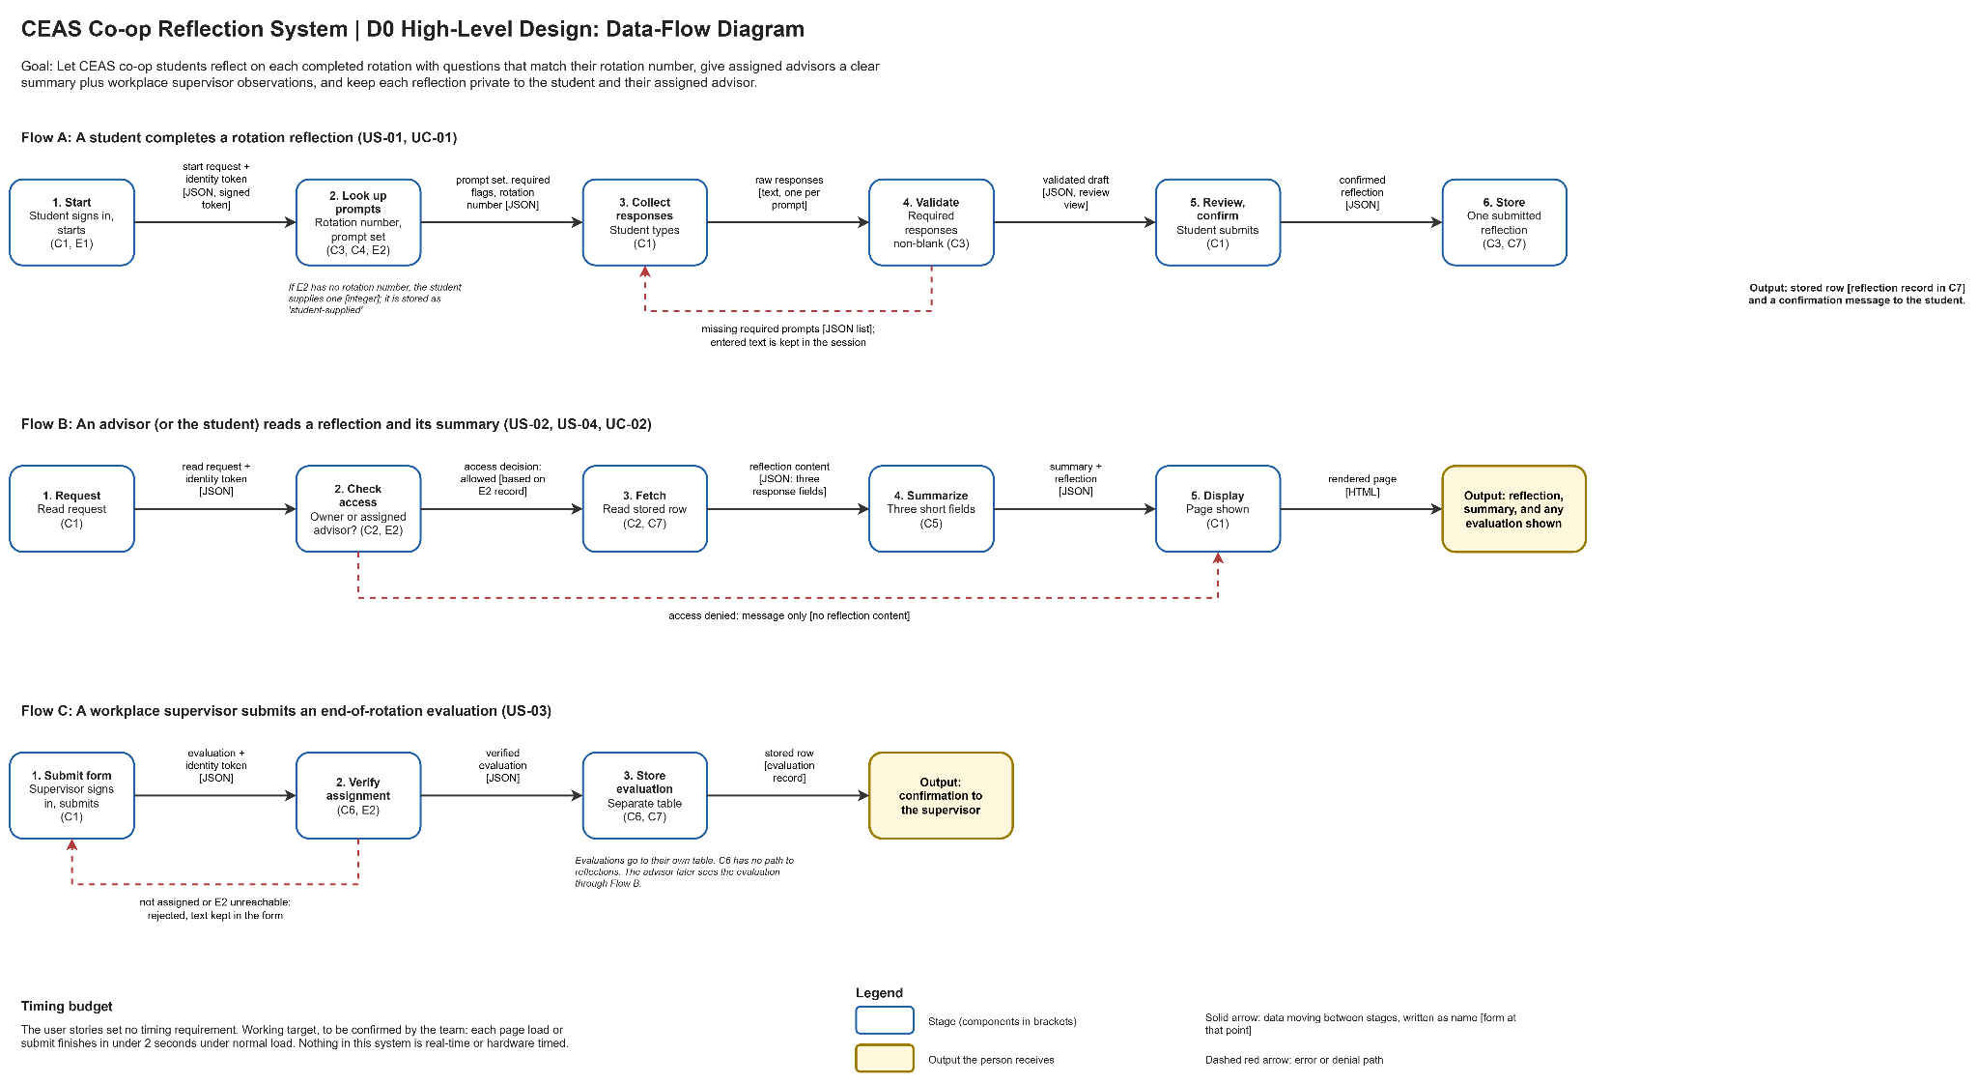

6. Architecture Pattern and Justification

Chosen Pattern(s): The CEAS Co-op Reflection System primarily uses client-server architecture. The C1 Web Front End acts as the client, while the backend components like the Reflection Service, Access Control Service, Summary Generator, and Supervisor Evaluation Service act as server-side services. The system follows a layered architecture, separating the user interface, application logic, access control, and data storage. The pipeline pattern is used for the reflection workflow as data moves from the student interface through validation and processing before being stored in the Reflection Database.

Fit to the Problem: Client-server fits the project because students, advisors, and workplace supervisors need to access the same centralized system through a web interface. Separating the interface, business logic, and database also supports the different responsibilities already defined for the system components.

Team Skills: The architecture matches the team’s experience with web development, backend services, databases, and APIs. It also lets team members work on different parts of the system while keeping the connections between components clear.

Performance and Timing: The system does not need instant real-time processing. The reflection submissions, summaries, and supervisor evaluations can be handled through normal web requests. Tasks that are slower, like generating summaries, can be handled separately from the front end.

Scalability: The design can support more students, advisors, reflections, and co-op rotations as the system grows. Backend services can also be expanded without changing the whole system.

Hardware Constraints: No special hardware. Users bring an ordinary browser on a laptop or phone.

Rejected Pattern: The team rejected microservices as the main architecture. Microservices separates the system into many independently deployed services, however that would add extra complexity for a project of this size. The client-server and layered design is simpler while still keeping the system organized.

7. Decision Log

Decision | Alternatives Considered | Reason
Use university sign-in for user authentication. | Create our own account and password system. | University sign-in avoids having to manage passwords ourselves and aligns with existing university records.
Keep reflection prompts in a separate Prompt Configuration Store. | Hard-code the prompts directly into the Reflection Service. | Keeping the prompts separate makes them easier to update if questions or rotation requirements change.
Use one Access Control Service to manage access to reflections. | Have each service check access separately. | A single Access Control Service keeps access rules consistent and helps make sure reflections are only available to the student and their assigned advisor.
Keep supervisor evaluations separate from student reflections. | Handle reflections and supervisor evaluations through the same service. | Keeping them separate helps prevent workplace supervisors from gaining access to private student reflections.
Allow students to enter their rotation number if it is unavailable from university records. | Prevent the student from continuing until the university record is available. | Allowing the student to enter the rotation number lets them continue their reflection even if that information is temporarily unavailable.

